//Athul M B
//roll no -20
//arithmeticcalculator

echo -n "Enter a two number:"
read a
read b
echo "choose an operater"
echo "1.addition"
echo "2.subraction"
echo "3.multiplication"
echo "4.division"
read c
case $c in
1) result=$((a + b)) ;;
2) result=$((a - b)) ;;
3) result=$((a * b)) ;;
4) result=$((a / b)) ;;
*) echo "invalid operator:"
return 1 ;;
esac
echo "result: $result"

student@dl-14:~/shell$ ./arithematiccalculator.sh
Enter a two number:1
7
choose an operater
1.addition
2.subraction
3.multiplication
4.division
1
result: 8
student@dl-14:~/shell$ ./arithematiccalculator.sh
Enter a two number:2
7
choose an operater
1.addition
2.subraction
3.multiplication
4.division
3
result: 14

//Athul M B
//rollno-20
//palindrome

echo -n "Enter a number : "
read n
copy=$n
rev=0
while [ $n -gt 0 ]; do
digit=$((n % 10))
rev=$((rev * 10 + digit))
n=$((n / 10))
done
echo "The reverse of the number is : $rev"
if [ $copy -eq $rev ]; then
echo "The number is a palindrome."
else
echo "The number is not a palindrome."
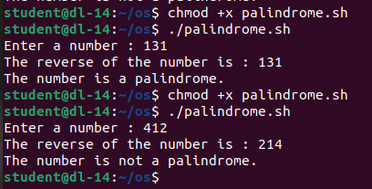
fi

//Athul M B
//roll no -20
//factorial

echo -n "Enter a number : "
read n
c=$n
fact=1
while [ $n -gt 0 ]; do
fact=$((fact * n))
n=$((n - 1))
done
echo "The factorial of $c is $fact"

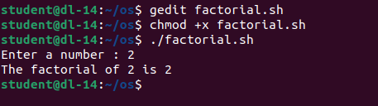

//Athul M B
//roll no -20
//sum of digits

echo -n "Enter a number : "
read n
copy=$n
sum=0
while [ $n -gt 0 ]; do
digit=$((n % 10))
sum=$((sum + digit))
n=$((n / 10))
done
echo "The sum of digits of $copy is $sum"

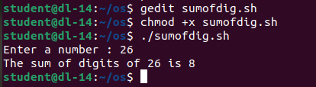

//Athul M B
//roll no -20
//odd or even

echo -n "Enter a number : "
read n
if [ $((n % 2)) -eq 0 ]; then
echo "The number is even"
else
echo "The number is odd"
fi

